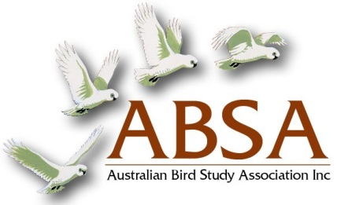
2016 CONFERENCE REGISTRATION

Name: ____________________________________________

Address: ____________________________________________
____________________________________________

Email: ____________________________________________

PLEASE complete and send
this form to:
The Treasurer
Australian Bird Study Association
PO Box 1867
Penrith BC NSW 2751
Australia
OR scan and email to:
info@absa.asn.au

Registration $60.00

Registration includes:
Tea/Coffee on arrival
Morning and Afternoon Tea
Cold Lunch

Please state allergies and dietary requirements: _________________________

PAYMENT DETAILS

Please circle method of payment:

Cheque

Debit my Credit Card: Visa Mastercard

Card No. _ _ _ _ _ _ _ _ _ _ _ _ _ _ _ _ Expiry date: ______________

Signature: ________________________________________________________________

Direct Deposit into the ABSA Account

Australian Bird Study Association Inc. BSB: 062-229 Account No: 00901789
Don’t forget to include your Surname first as some banks limit the number of letters that can be displayed on the transaction.

